This text document was created to allow golf planners and committees the ability to easily add the Aquavation® offering to your tournament sponsorship communications.
SIMPLY COPY & PASTE page 2 to bundle with your existing sponsorship tiers, add your tournament amenities and publish with your desired market pricing.
A Bottle Bingo™ Primer
Your sponsor is providing a personalized gift bottle for each player with their digital logo next to a unique bingo number.
You are offering your potential sponsor the right to be at your event interacting with a fun bingo game on the course.
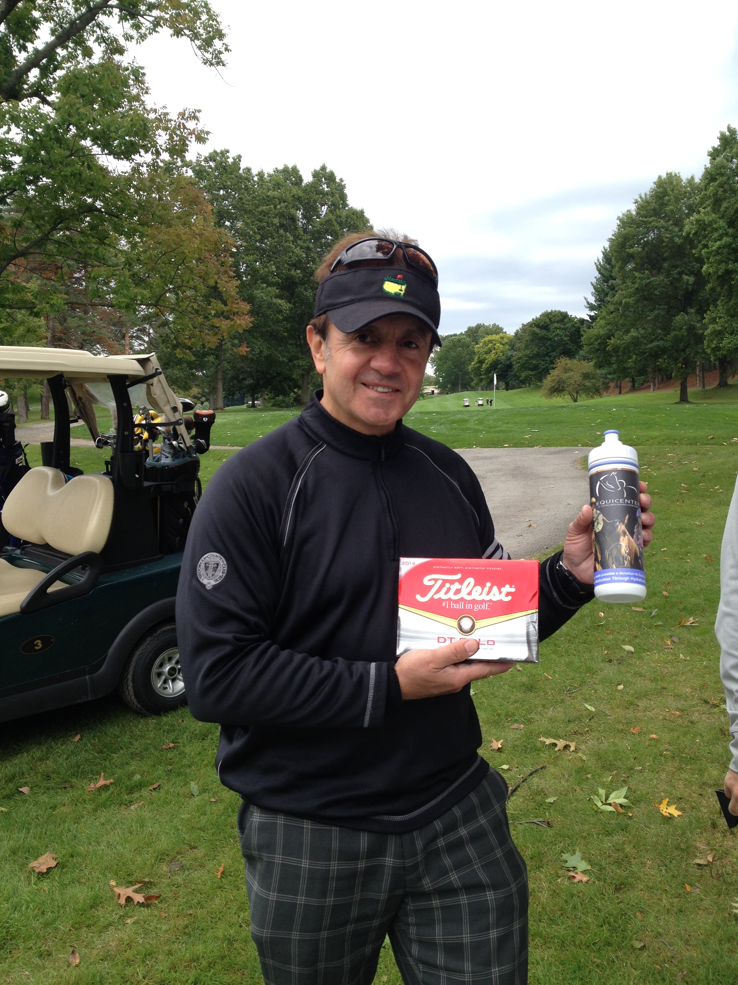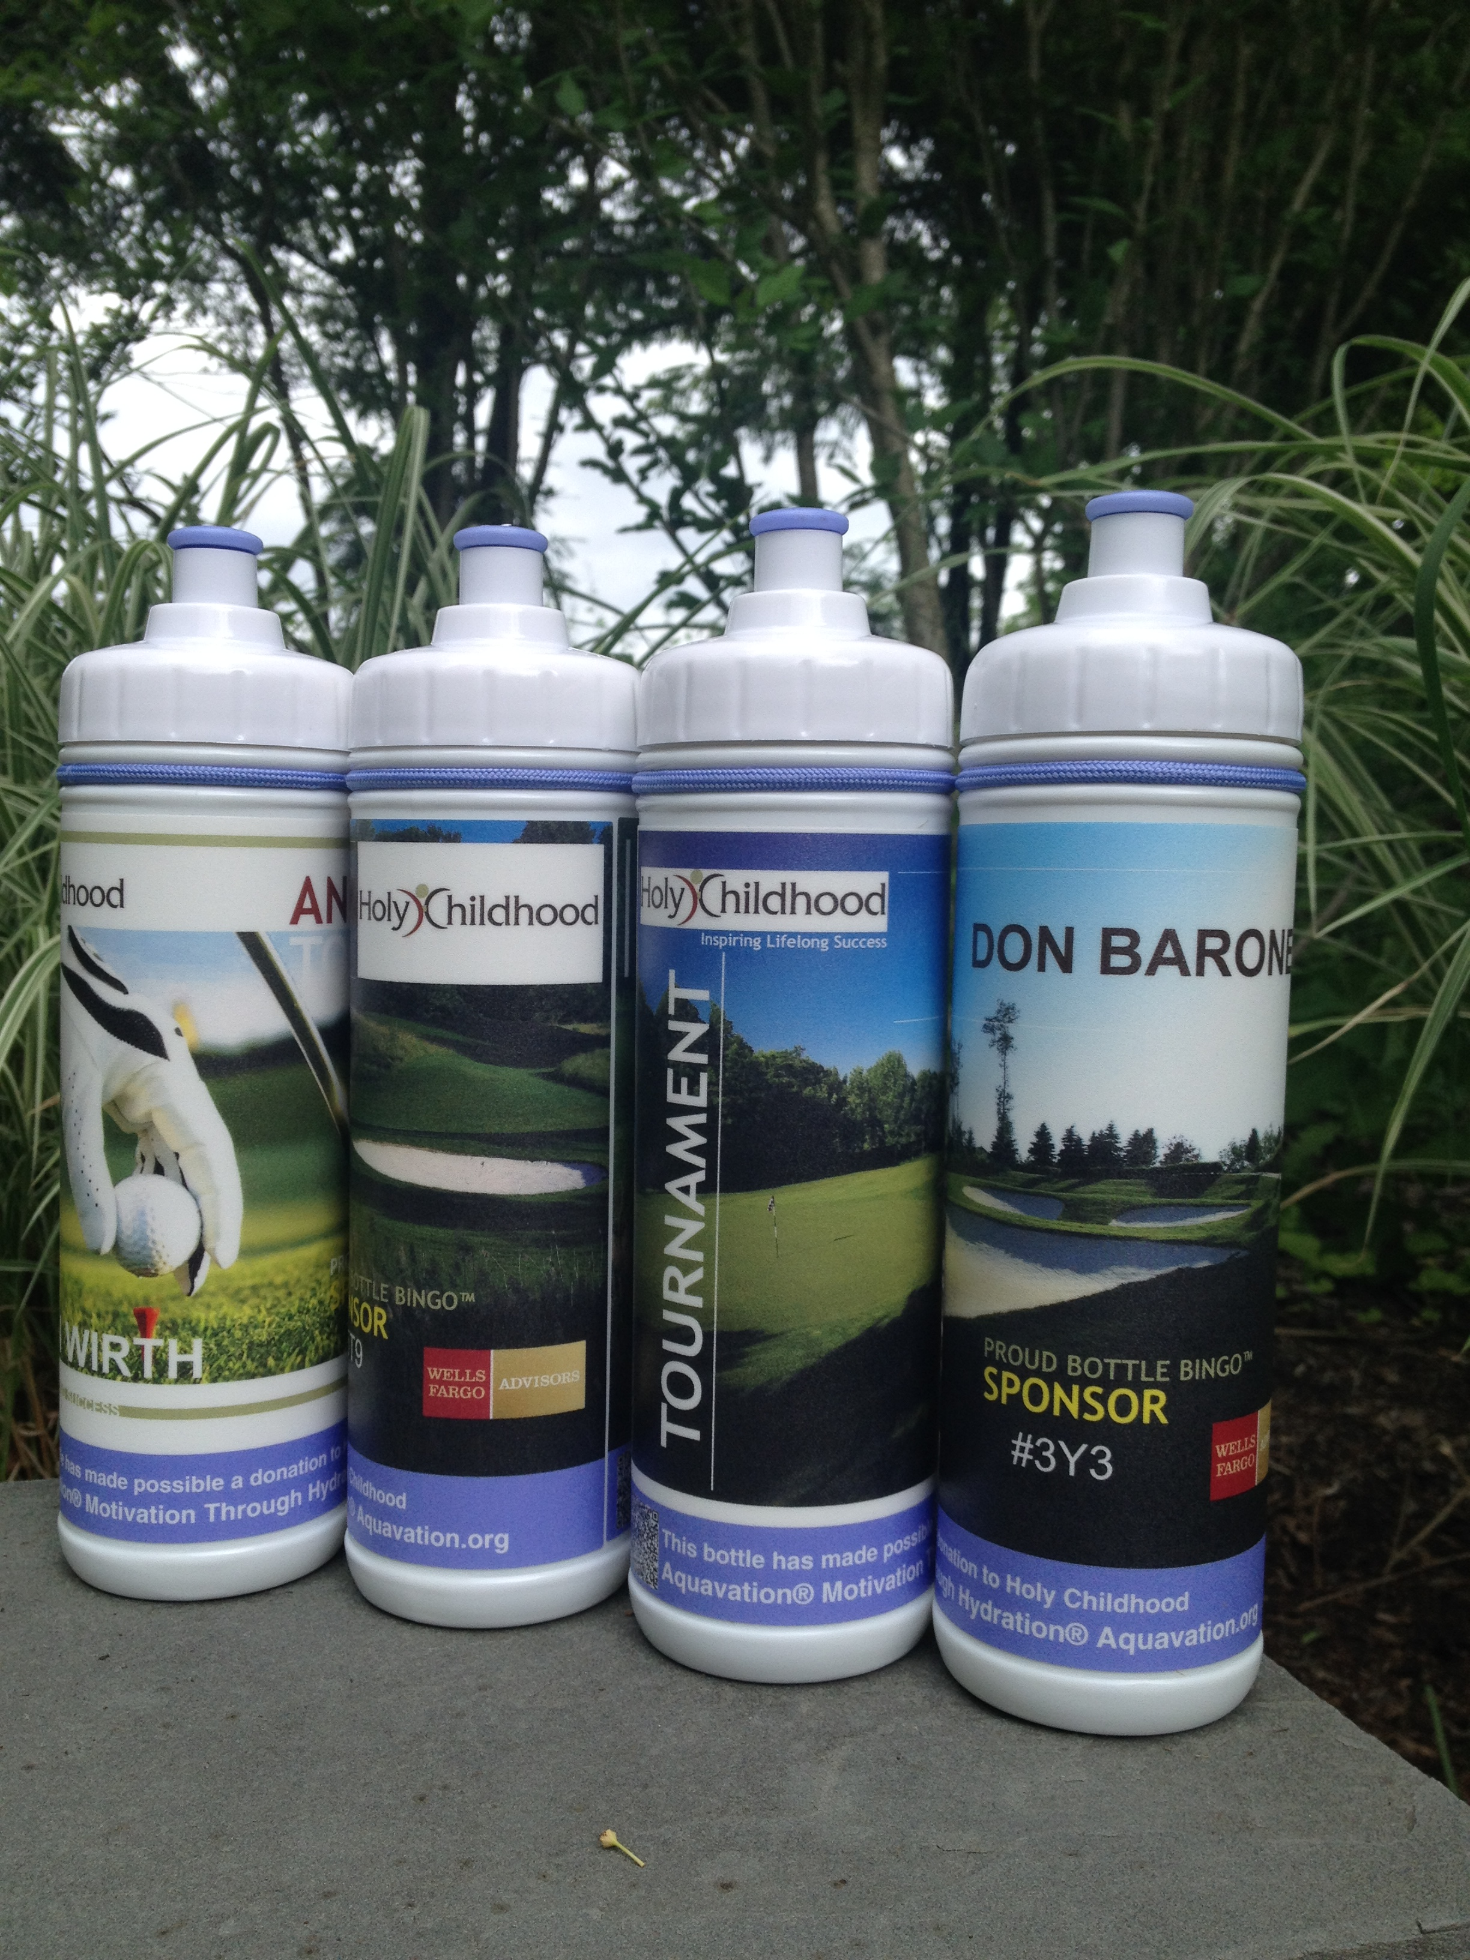
Watch Video of Bottle Bingo™ in Action
(3) Once you have sold your sponsorship Contact
Golf@Aquavation.Org
[Copy and Paste the following:]
Bottle Bingo™ Sponsor:
Be the memorable sponsor at our tournament. Together, we will partner with Aquavation® to create a personalized water bottle gift, which will be the first thing our golfer’s see sitting in their cart. Each bottle will have your logo and a variable bingo number. As our sponsor your will have the unique opportunity to position at a designated hole interacting with your target market to provide the most fun gift experience ever seen at a golf event! Best of all, your logo goes home and is seen in the community long after the tournament ends.
Aquavation® Bottle Bingo™ Sponsor
Limited to One
MKT Price + Representatives with player gifts at tournament day

- Name & digital logo on personalized water bottles presented to each golfer with your brand carried into the community long after the event.
- Your brand will appear next to a unique bingo number on each player bottle.
- Product presence at designated hole where your representatives engage players in your target market with a round of Bottle Bingo™. You will present winners with your logo’d merchandise and give-aways of your choosing.
- Listed in tournament program
- Placement on the web site thank you page with link to Sponsor’s Web site
- Recognition at luncheon & tournament awards dinner
- Two (2) tournament full access passes

